Name: M Shan Iftikhar

Roll No: BSAI-4A-017

Lab task 9

Text Classification using Logistic Regression on mobiles sales data

1. Import libraries

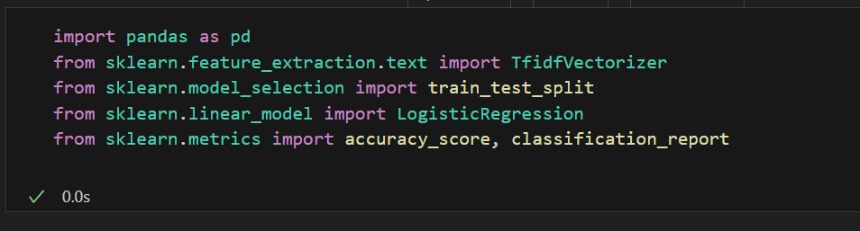

1. Dataset Used

* Product, Brand, Product Specification, Price, etc.

1. Steps Performed

* Data Preperation

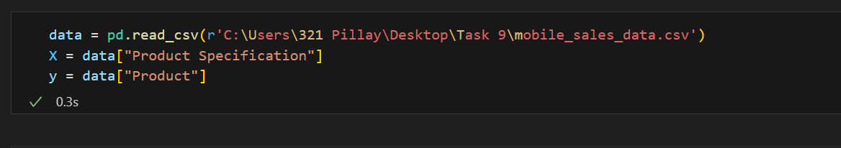

* Text Vectorization

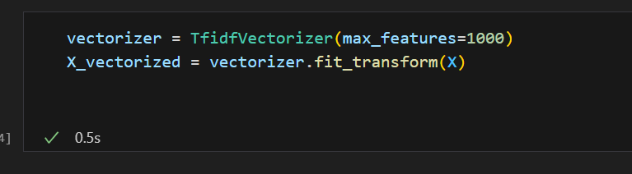

1. Model Training

* Split data and trained Logistic Regression

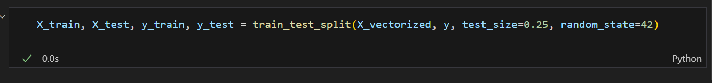

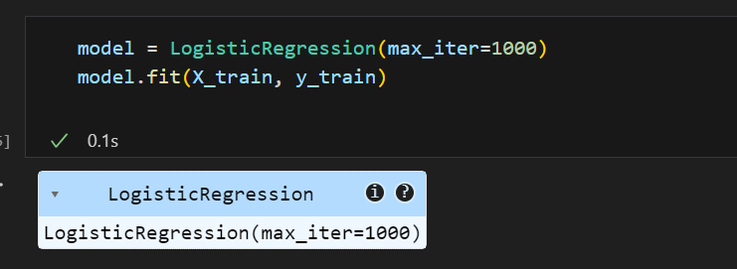

1. Evaluation And Result

* Calculated accuracy and classification report

